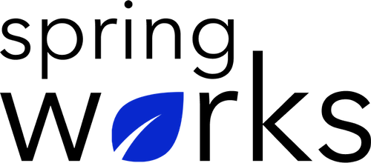
Free Template – Employee Induction Survey

Find out how your recruits are setting in

With this employee induction survey template, you can know if a candidate is a right fit, identify sources to acquire candidates, and how you can improve your induction and recruitment processes. Copy this template to your Google Drive and customize it for your organization.

Communication (to be added as review instructions):

Your responses to this survey are anonymous. The leaders are committed to analyzing your results and taking action. Please answer this quick survey by <HOUR OF THE DAY> on <DATE>.

Thank you for your time. Your responses will help our organization become a better place to work. If you have any questions about the survey, please contact [insert name of contact person].

Demographic Information:

The following information is requested so that meaningful analysis and comparisons of group results can be made. Please check the circle corresponding to your answer.

Q: Your Gender:

- Male
- Female

Q: Your Department:

- Marketing
- Operations
- Tech
- Accounting
- HR

Employee Induction Questionnaire

To answer clearly what you think or feel about each item, please follow these steps:

- Read each item fully before you start to mark your answer.
- Pick the one answer which most nearly says what you think or how you feel.
- While completing the questions, be sure to read the special instructions which are included.

Choose the most appropriate answer:

Q: On a scale of 1 to 10, how would you rate your Overall, how would you rate the induction process??

1 | 2 | 3 | 4 | 5 | 6 | 7 | 8 | 9 | 10

Q: Did you feel welcomed by staff?

0 | 1 | 2 | 3 | 4 | 5 | 6 | 7 | 8 | 9 | 10

Q: How satisfied were you with the information provided to you during your induction period?

0 | 1 | 2 | 3 | 4 | 5 | 6 | 7 | 8 | 9 | 10

Q: How would you rate the support and assistance as you settled in from team members and managers?

- Very poor
- Poor
- Neutral
- Good
- Very good
Q: What could we improve on as part of our induction process?

- Information provided before the start date
- Information provided during the induction period
- Support from managers
- Support from team members
- Training specific to my role
- Other

Q: I will still be working here 3 years from now:

- Strongly agree
- Agree
- Neutral
- Disagree
- Strongly disagree

Q: Did the information you received before your first day help you know what to expect and where to go?

- Yes
- No

Q: I will recommend this organization to my friends and family:

- Strongly agree
- Agree
- Neutral
- Disagree
- Strongly disagree

Q: I am satisfied to be working with this organization:

- Strongly agree
- Agree
- Neutral
- Disagree
- Strongly disagree

Q: How well was your supervisor prepared for your arrival?

⭐⭐⭐⭐⭐

Q: There is no discrepancy between my current role and what was described:

- Strongly agree
- Agree
- Neutral
- Disagree
- Strongly disagree

Q: Do you have any other feedback on your induction?

Thanks for your response!

